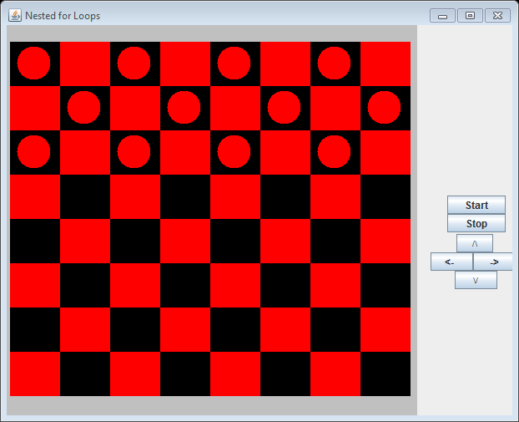

**Figure 5.12 The output produced by the application CheckerBoard.**